Singular Value Decomposition
Teaching Notes
A from-scratch guide to the linear algebra underneath PCA, and to its second life: filling in missing values in a sparse ratings matrix to power product recommendations. Builds directly on the PCA notes.

Contents

1. One Piece of Math, Two Very Different Jobs
The PCA notes showed how to find the directions along which a dataset spreads out the most. Under the hood, that search is powered by a single, general-purpose piece of linear algebra called Singular Value Decomposition (SVD). SVD isn't specific to PCA at all: it works on any matrix, not just centered, scaled data, and it has a second, very practical use that has nothing to do with reducing the number of features: filling in the missing values in a sparse table, which is exactly the problem behind product recommendations. This note covers both faces of SVD: the math itself, and this second application.
Every matrix X, of any shape, can be factored into three pieces:
X = U Σ Vᵀ
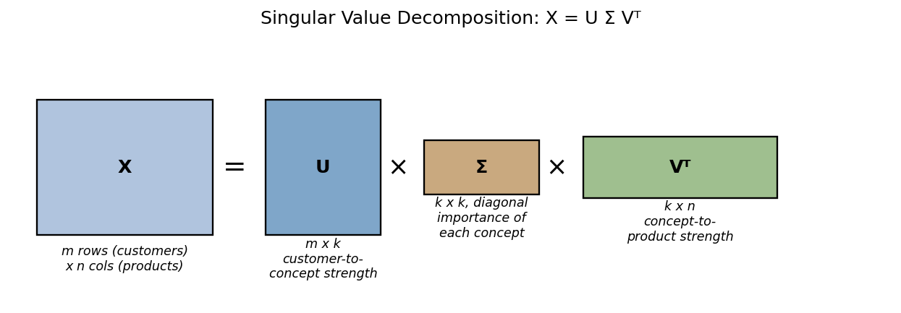
Figure 1. The shapes involved. X is m rows × n columns. U holds row-to-concept strengths, Σ is a diagonal matrix ranking how important each concept is, and Vᵀ holds concept-to-column strengths.
- U: how strongly each row (e.g. each customer) relates to each of the new underlying “concepts” SVD discovers.
- Σ (Sigma): a diagonal matrix of singular values, always sorted largest to smallest, one per concept, saying how much of the matrix's total pattern that concept accounts for.
- Vᵀ: how strongly each original column (e.g. each product or feature) relates to each concept.
“Concept” here is doing a lot of work, it's just a direction, an axis, discovered purely from the numbers, the same way a principal component was in the PCA notes. In fact, when X is centered and scaled, the concepts SVD finds and the principal components PCA finds are literally the same thing.

2. The Connection to PCA, Made Explicit
PCA's eigenvector calculation (Section 3 of the PCA notes) and SVD are not two different techniques that happen to agree, SVD is what PCA is doing internally. When you run PCA on a centered, scaled data matrix X:
- The columns of V (equivalently, the rows of Vᵀ) are exactly PCA's principal component directions.
- The singular values in Σ, once squared and divided by (n−1), are exactly PCA's eigenvalues, the explained variance of each component.
- U Σ gives exactly PCA's projected scores, each row's coordinate along every component.
On the 18-feature credit risk data from the PCA case study, running PCA and running raw SVD on the same standardized matrix produces components that match to four decimal places (up to an arbitrary sign flip, a direction and its exact opposite describe the same axis, so a sign difference is expected and harmless). This isn't a coincidence or an approximation, it's the same computation under two names. PCA is best thought of as “SVD, applied to centered data, with the output relabeled.”

3. A Tiny Worked Example: Discovering Hidden “Taste” Concepts
Take four customers who have rated three movie genres, Action, Romance, and Comedy, on a 1–5 scale:
Customer | Action | Romance | Comedy
C1 | 5 | 1 | 3
C2 | 4 | 1 | 2
C3 | 1 | 5 | 3
C4 | 2 | 4 | 3

Even without being told, you can probably see two “tastes” at work here: C1 and C2 clearly favor Action, C3 and C4 clearly favor Romance, and everyone is lukewarm-to-positive on Comedy. SVD discovers exactly this kind of structure automatically, purely from the numbers:
Singular values: σ₁ = 9.87, σ₂ = 4.75, σ₃ = 0.33
σ₁² alone accounts for 81.2% of the matrix's total squared energy;
σ₁² + σ₂² together account for 99.9%
The third singular value (0.33) is tiny compared to the first two, telling us this ratings table is, for all practical purposes, built from just two underlying concepts, not three. Reconstructing the matrix using only the strongest concept (rank-1) versus the two strongest (rank-2) shows exactly what each concept is buying us:
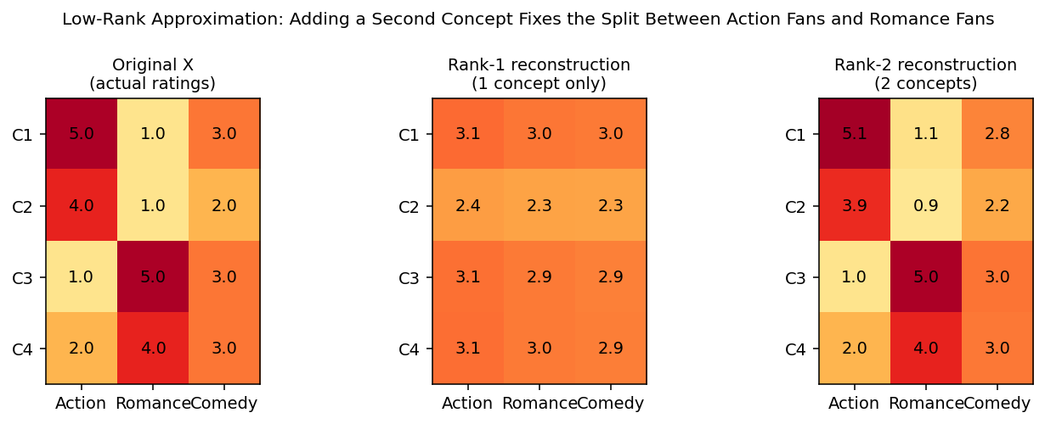
Figure 2. Left: the actual ratings. Middle: rebuilt from 1 concept only, everyone gets flattened to nearly the same lukewarm ~3, the single concept can only capture “overall rating level,” not who prefers what. Right: rebuilt from 2 concepts, essentially recovers the original table exactly, the second concept is exactly the Action-vs-Romance taste split.
This is the same lesson as the PCA scree plot, expressed differently: the first concept captures the single biggest pattern (here, roughly “overall enthusiasm”), and it takes a second concept to separate out the next distinguishing pattern (Action-lovers vs. Romance-lovers). A third concept exists mathematically but adds almost nothing, exactly what σ₃ = 0.33 already told us.

4. Low-Rank Approximation: Keep the Strong Patterns, Drop the Rest
Truncating a matrix's SVD to its k largest singular values, and rebuilding it from only those, is called a rank-k approximation. It's the same idea as keeping only the first few principal components: throw away the weakest, most noise-like concepts, and keep only the patterns strong enough to matter. A classic way to make this tangible is to treat a grayscale image as just another matrix (pixel rows × pixel columns) and compress it the same way:
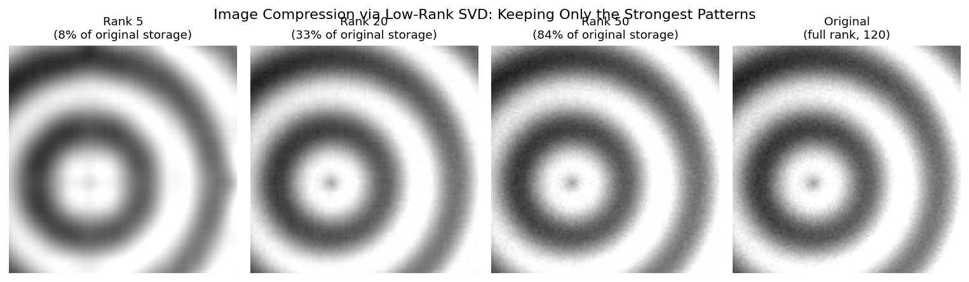
Figure 3. A 120×120 pixel image, reconstructed from progressively more singular values. Rank 5 already captures the overall ring pattern but blurs away fine texture; rank 50 is visually indistinguishable from the original, while storing only 84% of the original data. Captured energy: 99.8% at rank 5, 99.9% at rank 20, 100% at rank 50.
The number of values needed to store a rank-k approximation of an m×n matrix is k×(m+n+1) (the k columns of U, k singular values, and k rows of Vᵀ), versus m×n for the full matrix. Whenever a matrix's real structure is simpler than its raw size suggests, low-rank SVD compresses it with very little loss, exactly what made the rank-2 reconstruction of the tiny ratings example in Section 3 nearly exact.

5. Second Life: Filling In a Sparse Ratings Matrix
The case study applies exactly this idea to a real, messier problem: a bank has 300 customers and 41 products, but any one customer has only tried a handful of them, only about 36% of all possible customer-product pairs have an actual rating. The rest are blank. Unlike the tidy 4×3 example above, this matrix has holes in it, SVD can't be run on missing values directly.
- Every blank cell is first filled with a neutral placeholder (that product's average rating among customers who did rate it), just to give SVD a complete matrix to start from.
- TruncatedSVD is fit on this filled-in matrix and immediately kept to only its top k singular values/vectors, exactly the rank-k approximation from Section 4.
- Multiplying the truncated U, Σ, and Vᵀ back together produces a fully dense matrix of predicted ratings, including brand-new estimates for every cell that was originally blank.
The key discipline: some of the known ratings are held out (never shown to the model) purely to check its guesses, an 80/20 train/validation split of the actual observed ratings. This mirrors exactly the no-peeking rule used throughout, the model is judged only on ratings it never saw.

6. Choosing k: Validation, Not Intuition
How many concepts (k) should the recommendation model keep? The temptation is to assume “more is more faithful, so more is better,” but that isn't what happens once real, sparse, noisy data is involved:
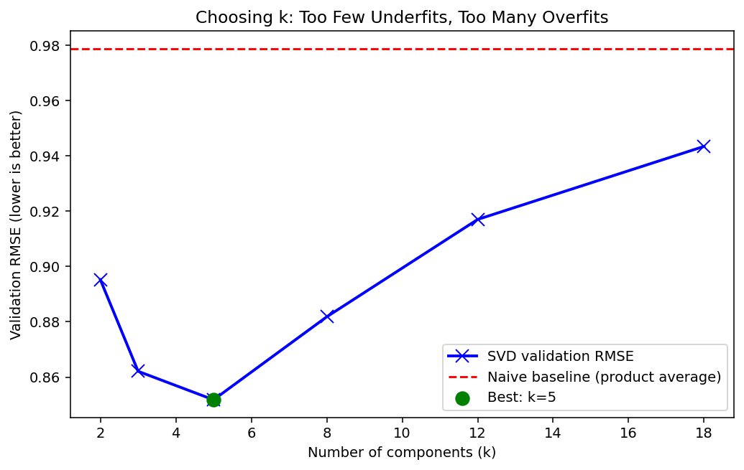
Figure 4. Validation RMSE (root mean squared error, how far off predicted ratings are from actual held-out ratings) at k = 2, 3, 5, 8, 12, 18. RMSE improves sharply up to k=5, then gets worse.
This is overfitting, the exact same lesson as the PCA scree plot, showing up here as a validation curve instead: with too few concepts, the model can't capture real customer-taste differences (it underfits). With too many, it starts fitting the noise introduced by the crude mean-filling used for originally-missing cells (it overfits), and validation performance actually gets worse, not just slower to compute. k=5 gives the best validation RMSE, 0.8518, compared to a naive “just guess the product's average rating” baseline of 0.9787, a 13.0% reduction in prediction error. Nothing about this k=5 choice was assumed in advance, it was found by checking predictions against ratings the model never got to see.

7. Strengths, Weaknesses, and When to Use SVD

Strengths
- General-purpose: works on any matrix, unlike PCA it doesn't require centered or even square data.
- Naturally handles sparse, incomplete data (after an initial fill-in step), making it a workhorse for recommendation systems.
- Low-rank approximation gives a principled, tunable way to trade off compression against accuracy, for features, images, or ratings alike.
- Deterministic and mathematically well understood, same input always produces the same decomposition.

Weaknesses
- Requires a complete matrix to start from, missing values must be filled in somehow first, and that filling choice can itself bias results.
- Like PCA, only captures linear structure in the data.
- The rank k is a real hyperparameter that must be validated (Section 6), not guessed, picking it too high actively hurts accuracy, it doesn't just waste compute.
- Concepts discovered by SVD aren't guaranteed to have a clean, nameable business meaning the way PC1/PC2/PC3 did in the PCA notes, sometimes they do (Section 3's Action-vs-Romance split), sometimes they're harder to interpret.

Rule of thumb: reach for SVD (via TruncatedSVD or an equivalent) any time you have a large, sparse matrix of interactions, ratings, purchases, clicks, and need to predict the missing cells. Reach for PCA specifically when the goal is dimensionality reduction on a complete, already-dense feature table, PCA is simply the standardized, centered special case of exactly the same underlying computation.

8. Summary Cheat Sheet
- SVD factors any matrix X into U Σ Vᵀ: row-to-concept strengths, concept importance (ranked), and concept-to-column strengths.
- PCA is SVD applied to centered, scaled data, the components and eigenvalues from PCA are literally V and (singular values)²/(n−1) from SVD.
- Truncating to the top k singular values gives a rank-k approximation, keep the strongest patterns, discard the rest, this is the basis of both PCA-style compression and image compression.
- SVD's second major use, beyond dimensionality reduction, is filling in sparse matrices, the basis of recommendation systems.
- Missing values must be filled in before SVD can run, then TruncatedSVD reconstructs a complete matrix, including predictions for the originally-missing cells.
- Choose k the same way you'd choose any hyperparameter: validate on held-out data. Too few concepts underfits, too many overfits to noise, exactly like the PCA scree plot's elbow, just visible here as a validation curve instead.

